Domain and Range

Key Points:

- The domain is the set of all possible input values for a relation.

- The range is the set of output values that result from the input values in a relation.

- The domain of a function includes all real input values that would not cause us to attempt an undefined mathematical operation, such as dividing by zero or taking the square root of a negative number.

- The domain of a function can be determined by listing the input values of a set of ordered pairs.
Example: Find the domain of the following function: {(2, 10), (3, 10), (4, 20), (5, 30), (6, 40)}.
Solution: First identify the input values. The input value is the first coordinate in an ordered pair. There are no restrictions, as the ordered pairs are simply listed. The domain is the set of the first coordinates of the ordered pairs: {2, 3, 4, 5, 6}.

- The domain of a function can also be determined by identifying the input values of a function written as an equation.
Example: Find the domain of the function $f\left(x\right)=x^{2}-1$.
Solution: The input value, shown by the variable x in the equation, is squared and then the result is lowered by one. Any real number may be squared and then be lowered by one, so there are no restrictions on the domain of this function. The domain is the set of real numbers. In interval form, the domain of f is $(-∞, ∞)$.

Example: Find the domain of the function $f\left(x\right)=\frac{x+1}{2-x}$.
Solution: When there is a denominator, we want to include only values of the input that do not force the denominator to be zero. So, we will set the denominator equal to 0 and solve for x.
$$2-x=0$$
$$-x=-2$$
$$x=2$$

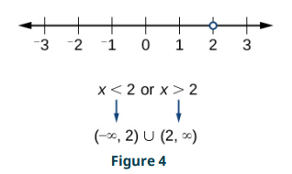
Now, we will exclude 2 from the domain. The answers are all real numbers where $x<2$ or $x>2$ as shown in Figure 4. We can use a symbol known as the union, $∪$, to combine the two sets. In interval notation, we write the solution: $(-∞, 2)∪(2, ∞)$.

Example: Find the domain of the function $f\left(x\right)=\sqrt{7-x}.$
Solution: When there is an even root in the formula, we exclude any real numbers that result in a negative number in the radicand. Set the radicand greater than or equal to zero and solve for x.

$$7-x≥0$$
$$-x≥-7$$
$$x≤7$$

Now, we will exclude any number greater than 7 from the domain. The answers are all real numbers less than or equal to 7, or $(-∞, 7]$.

Example: Find the domain and range of $f\left(x\right)=2x^{3}-x$.
Solution: There are no restrictions on the domain, as any real number may be cubed and then subtracted from the result. The domain is $(-∞, ∞)$ and the range is also $(-∞, ∞)$.

Example: Find the domain and range of $f\left(x\right)=\frac{2}{x+1}$.
Solution: We cannot evaluate the function at -1 because division by zero is undefined. The domain is $(-∞, -1)∪(-1, ∞)$. Because the function is never zero, we exclude 0 from the range. The range is $(-∞, 0)∪(0, ∞)$.

Example: Find the domain and range of $f\left(x\right)=2\sqrt{x+4}$.
Solution: We cannot take the square root of a negative number, so the value inside the radical must be nonnegative.

$x+4≥0$ when $x≥-4$.

The domain of $f(x)$ is $[-4, ∞)$.
We then find the range. We know that $f\left(-4\right)=0$, and the function value increases as x increases without any upper limit. We conclude that the range of f is $[0, ∞)$.

- Interval values represented on a number line can be described using inequality notation, set-builder notation, and interval notation.
Example: Describe the intervals of values shown in Figure 6 using inequality notation, set-builder notation, and interval notation.
Solution: To describe the values, x, included in the intervals shown, we would say, “x is a real number greater than or equal to 1 and less than or equal to 3, or a real number greater than 5.”

Inequality | $1≤x≤3$ or $x>5$
Set-builder notation | $$\{x\left|1≤x≤3\right. or x>5\}$$
Interval notation | $$\left[1,3\right]∪\left(5,∞\right)$$

Remember that, when writing or reading interval notation, using a square bracket means the boundary is included in the set. Using a parenthesis means the boundary is not included in the set.

- For many functions, the domain and range can be determined from a graph.
Example: Find the domain and range of the function f whose graph is shown in Figure 9.

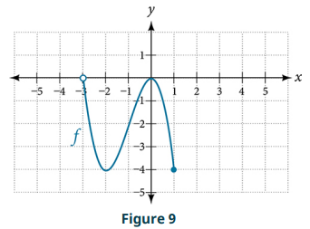
Solution: We can observe that the horizontal extent of the graph is –3 to 1, so the domain of f is $(-3, 1]$.
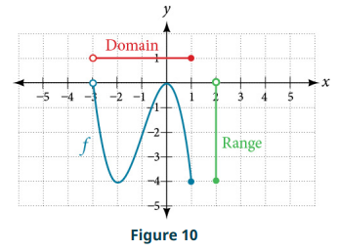
The vertical extent of the graph is 0 to -4, so the range is $[-4, 0)$. See Figure 10.

Example: Find the domain and range of the function f whose graph is shown in Figure 11.
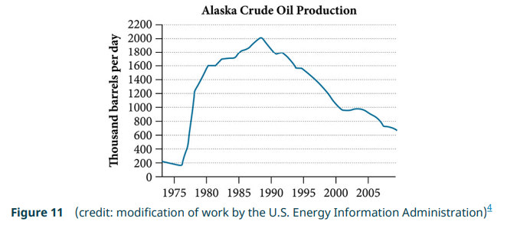

Solution: The input quantity along the horizontal axis is “years,” which we represent with the variable t for time. The output quantity is “thousands of barrels of oil per day,” which we represent with the variable b for barrels. The graph may continue to the left and right beyond what is viewed, but based on the portion of the graph that is visible, we can determine the domain as $1973≤t≤2008$ and the range as approximately $180≤b≤2010$. In interval notation, the domain is [1973, 2008], and the range is about [180, 2010]. For the domain and the range, we approximate the smallest and largest values since they do not fall exactly on the grid lines.

Domain and Range Videos
- Finding the Domain of a Function as a Set of Ordered Pairs: Example 1
- Finding the Domain of a Function: Example 2
- Finding the Domain of a Function Involving a Denominator: Examples 3-4
- Finding the Domain of a Function Involving an Even+ Root: Example 5
- Finding Domain and Range from a Graph : Example 6
- Finding the Domain and Range: Example 7
- Graphing a Piecewise Function: Example 8

Practice Exercises

Follow the directions for each exercise below:
- Find the domain and express your answer in interval notation: $f\left(x\right)=\frac{2}{3x+2}$.

- Find the domain and express your answer in interval notation: $f\left(x\right)=\frac{x-3}{x^{2}-4x-12}$.

- Find the domain and express your answer in interval notation: $f\left(x\right)=\frac{\sqrt{x-6}}{\sqrt{x-4}}$.

- Write the domain of the function $f\left(x\right)=\sqrt{3-x}$ in interval notation.

- Write the domain and range of the function using interval notation:
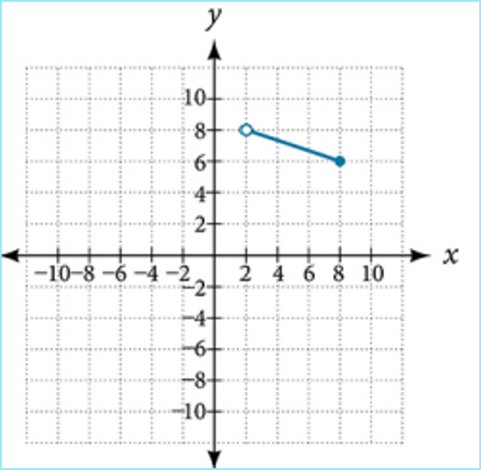
- Write the domain and range of the function using interval notation:
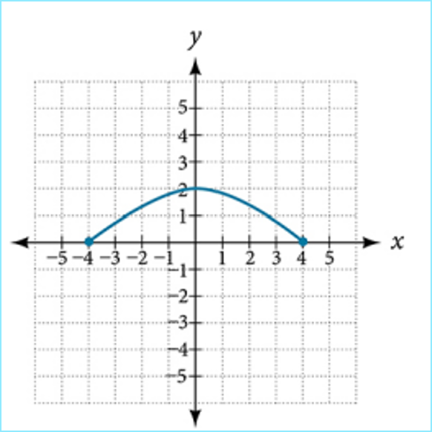

- Write the domain and range of the function using interval notation:
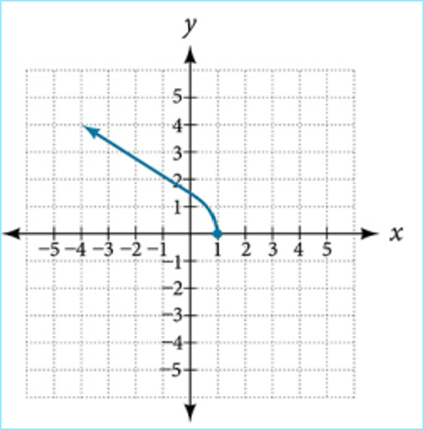

- Write the domain and range of the function using interval notation:

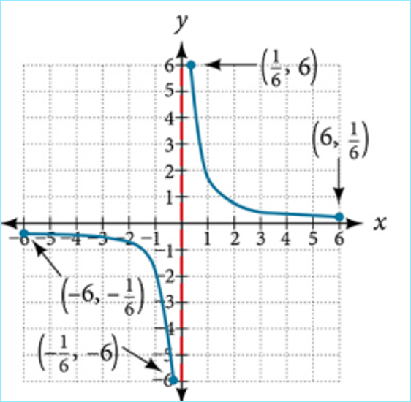

- Write the domain and range of the function using interval notation:

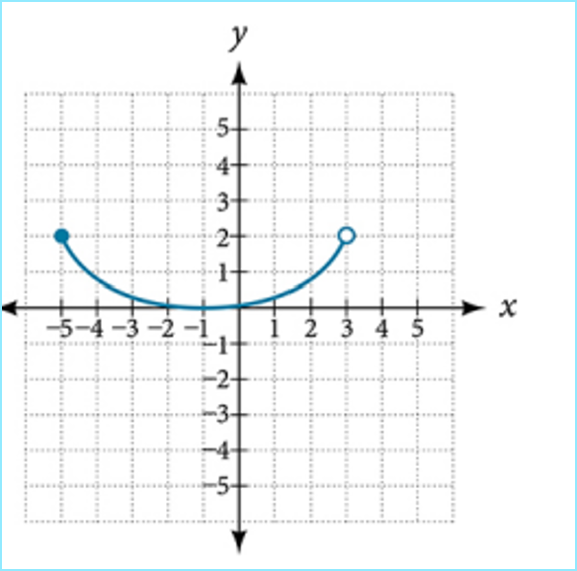
- Write the domain and range of the function using interval notation:
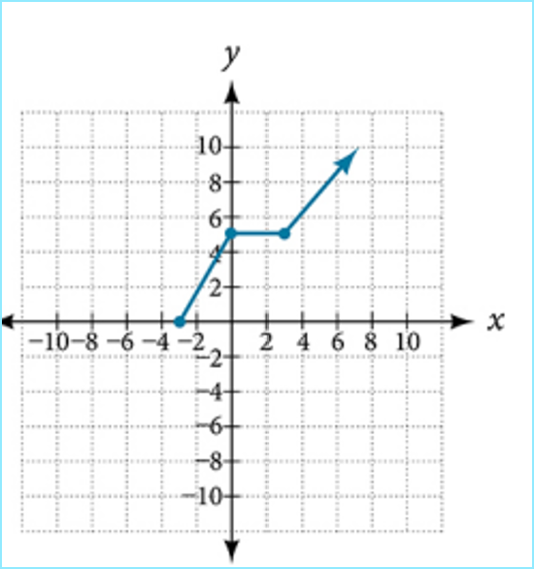

Answers:
- Domain: $(-∞,-\frac{2}{3})∪(-\frac{2}{3},∞)$

- Domain: $\left(-∞, -2\right)∪\left(-2,6\right)∪\left(6,∞\right)$

- Domain: $[6, ∞)$

- Domain: $(-∞, 3]$

- Domain: $(2, 8]$; Range: $[6, 8)$.

- Domain: $[-4, 4]$; Range: $[0, 2]$.

- Domain: $(-∞, 1]$; Range: $[0, ∞)$.

- Domain: $\left[-6, -\frac{1}{6}\right]∪\left[\frac{1}{6}, 6\right]$; Range: $\left[-6, -\frac{1}{6}\right]∪\left[\frac{1}{6}, 6\right]$

- Domain: $[-5, 3)$; Range: $[0, 2]$.

- Domain: $[-3, ∞)$; Range: $[0, ∞)$.

